

FPT University
Training Center Programming FPT - APTECH



SUPPORTIVE LEARNING

❖ SEM : IV
❖ CLASS : C0810G
❖ Group : Group 2
❖ TEACHER : Đỗ Quốc Bình
❖ Members :
- Dương Văn Định (Leader)
- Phan Văn Tuyền
- Trần Trung Hiếu
- Phạm Xuân Nam
- Vũ Đức Giang

- Problem Definition:
- Problem Abstraction: The thirst for learning, upgrading technical skills and applying the concepts in real life environment at a fast pace is what the industry demands from IT professionals today. However busy work schedules, far-flung locations, and unavailability of convenient time-slots pose as major barriers when it comes to applying the concepts into realism. And hence the need to look out for alternative means of implementation in the form of laddered approach.
- The Current System: The above truly pose as constraints especially for our students too! With their busy schedules, it is indeed difficult for our students to keep up with the genuine and constant need for integrated application which can be seen live especially so in the field of IT education where technology can change on the spur of a moment. Well, technology does come to our rescue at such times!!
- The Proposed System: Keeping the above in mind and in tune with our constant endeavour to use Technology in our training model, we at Aptech have thought of revolutionizing the way our students learn and implement the concepts using tools themselves by providing a live and synchronous eProject learning environment!
- Development Environment:
Hardware :
- Server:
- Pentium IV 3.06GHZ,RAM 1GB,HDD 160GB…
- Client:
- Pentium III 900GHZ,RAM 128MB,Sound & VGA Card…
Software :
- Server:
- OS Windows Server 2000 or Windows Server 2003.
- MS SQL Server 2005.
- Client:
- Window98 or higher operating system.

Developer Tools :
- Language Used : Java Web Application and JSF 2.0 PrimeFaces 2.2.1.
- Database : MS SQL Server 2005
- Design tool : Netbean 6.9.1

- Glassfish 3.0 or higher.

- Requirements and business Flow:
- Customer Requirement Specification:

  - System Requirement Specification :
- Student
- Staff
- Admin

  - Functionality for Student:

2.1. View Information:

Open website Student can view the brief description about Schools, about the assignments and about the news.

2.2. Login:

Students must login for upload or download

2.3. Feedback:

Student can give feedbacks about the site or ask the queries if any.

2.4. Mark:

a. View details marks of assignments by roll number.

b. The students should be able to view the marks that are assigned for their assignments, through the link marks

2.5. FAQ’s:

Student can view the FAQ’s as created by the admin.

  - Functionality for Staff:

3.1. View Information:

Open website Staff can view the brief description about Schools, about the assignments,and about the news.

3.2. Login:

a. Staff must login to view, delete, upload assignments.

b. Staff can viewing uploaded files by student by roll number.

c. The staff will assign the marks after evaluating the assignment once they are downloaded. The marks assigned will then be uploaded on the site through the links “marks”, based on the roll number.

d. Staff to answer students' questions.

- Functionality for Admin:

4.1. Login:
a. The administrator will have the rights for creating, editing and deleting the usernames and passwords (username and passwords are to be created based on the batch, year, and semester. These are unique for the whole batch) .
b. The administrator will have the right to answer the query, view or edit or delete the FAQs.
- Activity Diagram

1. Login Activity Diagram:
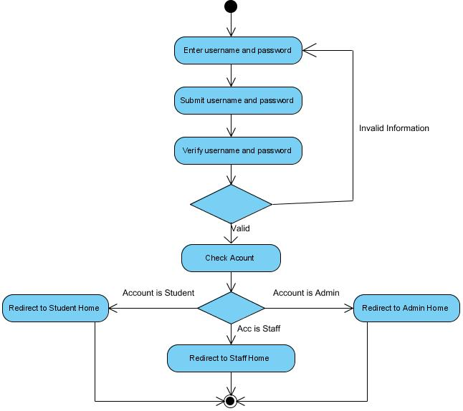

- Student Activity Diagram:

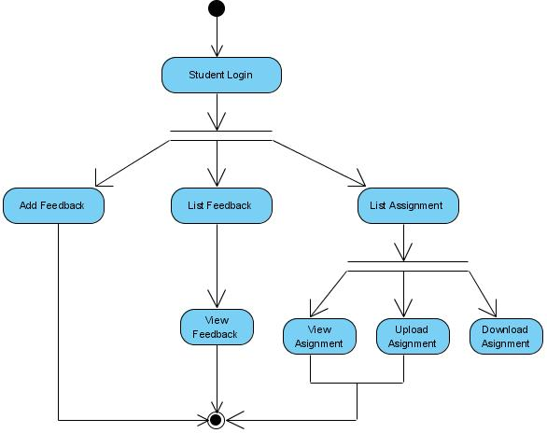

- Staff Activity Diagram:

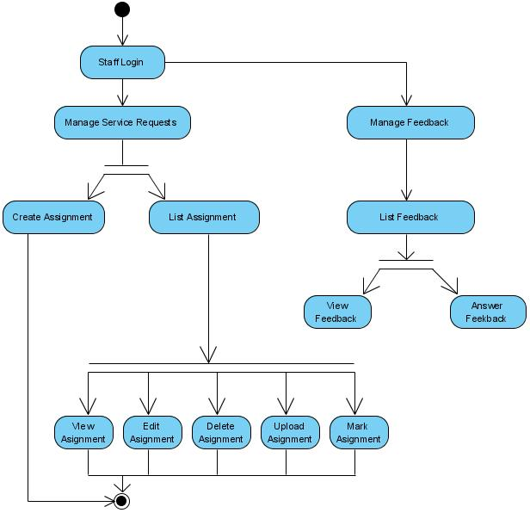

- Admin Activity Diagram:

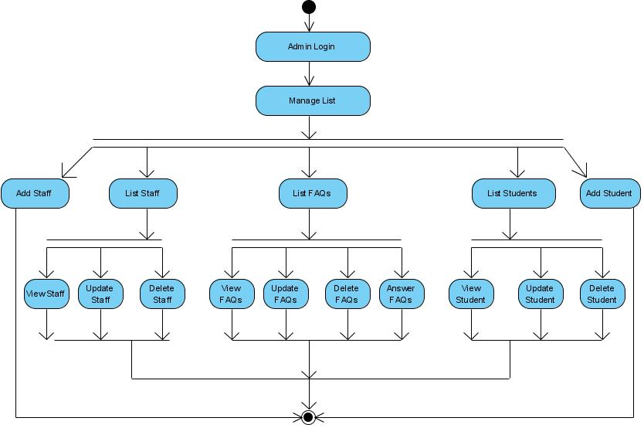

- Database Design

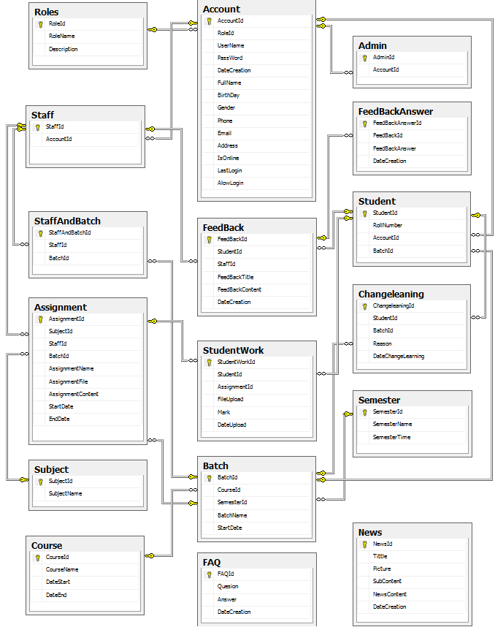

Table : Account
Field Name | Data Type | Null | Key | Description
AccountId | Int | No | PK | Stores the ID of Account
RoleId | Int | No | FK | Stores the ID of Role
UserName | Nvarchar(100) | Yes |  | Stores the userName of Account
PassWord | Nvarchar(100) | Yes |  | Stores the password of Account
DateCreation | DateTime | Yes |  | Stores the date when Create Account
FullName | Nvarchar(100) | Yes |  | Stores the full name of Account
BirthDay | DateTime | Yes |  | Stores the birth day of Account
Gender | Bit | Yes |  | Stores the gender of Account
Phone | Nvarchar(100) | Yes |  | Stores the number phone of Account
Email | Nvarchar(100) | Yes |  | Stores the address Email of Account
Address | Nvarchar(255) | Yes |  | Stores the address of Account

Table : Admin
Field Name | Data Type | Null | Key | Description
AdminId | Int | No | PK | Stores the ID of Admin
AccountId | Int | No | FK | Stores the ID of Account

Table : Assignment
Field Name | Data Type | Null | Key | Description
AssignmentId | Int | No | PK | Stores the ID of Assignment
SubjectId | Int | No | FK | Stores the ID of Subject
StaffId | Int | No | FK | Stores the ID of Staff
BatchId | Int | No | FK | Stores the ID of Batch
AssignmentName | Nvarchar(100) | Yes |  | Stores the Name of Assignment
AssignmentFile | Nvarchar(255) | Yes |  | Stores the Link File of Assignment
StartDate | DateTime | Yes |  | Stores the StartDate of Assignment
EndDate | DateTime | Yes |  | Stores the EndDate of Assignment

Table : Batch
Field Name | Data Type | Null | Key | Description
BatchId | Int | No | PK | Stores the ID of Batch
CourseId | Int | No | FK | Stores the ID of Course
SemesterId | Int | No | FK | Stores the Id of Semester
BatchName | Nvarchar(100) | Yes |  | Stores the Name of Batch
StartDate | DateTime | Yes |  | Stores the StartDate of Batch

Table : Course
Field Name | Data Type | Null | Key | Description
CourseId | Int | No | PK | Stores the ID of Course
CourseName | Nvarchar(100) | Yes |  | Stores the Name of Course
DateStart | DateTime | Yes |  | Stores the DateStart of Course
DateEnd | DateTime | Yes |  | Stores the DateEnd of Course

Table : FAQ
Field Name | Data Type | Null | Key | Description
FAQId | Int | No | PK | Stores the ID of FAQ
Question | Ntext | Yes |  | Stores the Question of FAQ
Answer | Ntext | Yes |  | Stores the Answer of FAQ
DateCreation | DateTime | Yes |  | Storers the DateCreation of FAQ

Table : FeedBack
Field Name | Data Type | Null | Key | Description
FeedBackId | Int | No | PK | Stores the ID of FeedBack
StudentId | Int | No | FK | Stores the ID of Student
FeedBackTitle | Nvarchar(100) | Yes |  | Stores the Title of FeedBack
FeedBackContent | Ntext | Yes |  | Stores the Content of FeedBack
DateCreation | DateTime | Yes |  | Stores the DateCreation of FeedBack

Table : FeedBackAnswer
Field Name | Data Type | Null | Key | Description
FeedBackAnswerId | Int | No | PK | Stores the ID of FeedBackAnswer
FeedBackId | Int | No | FK | Stores the ID of FeedBack
StaffId | Int | No | FK | Stores the ID of Staff
FeedBackAnswer | Ntext | Yes |  | Stores the Answer of FeedBack
DateCreation | DateTime | Yes |  | Stores the DateCreation of FeedBack

Table : News
Field Name | Data Type | Null | Key | Description
NewsId | Int | No | PK | Stores the ID of News
NewsCategoryId | Int | No | FK | Stores the ID of NewsCategory
Title | Nvarchar(100) | Yes |  | Stores the Title of News
Picture | Nvarchar(100) | Yes |  | Stores the Picture of News
SubContent | Nvarchar(150) | Yes |  | Stores the SubContent of News
NewsContent | Ntext | Yes |  | Stores the Content of News
DateCreation | DateTime | Yes |  | Stores the DateCreation of News

Table : NewsCategories
Field Name | Data Type | Null | Key | Description
NewsCategoryId | Int | No | PK | Stores the ID of NewsCategory
NewsCategoryName | Nvarchar(100) | Yes |  | Stores the Name of NewsCategory
Description | Nvarchar(200) | Yes |  | Stores the Description of NewsCategory

Table : Roles
Field Name | Data Type | Null | Key | Description
RolesId | Int | No | PK | Stores the ID of Roles
RoleName | Nvarchar(100) | Yes |  | Stores the Name of Roles
Description | Nvarchar(100) | Yes |  | Stores the Description of Roles

Table : Semester
Field Name | Data Type | Null | Key | Description
SemesterId | Int | No | PK | Stores the ID of Semester
SemesterName | Nvarchar(100) | Yes |  | Stores the Name of Semester
SemesterTime | Int | Yes |  | Stores the Time of Semester

Table : Staff
Field Name | Data Type | Null | Key | Description
StaffId | Int | No | PK | Stores the ID of Staff
AccountId | Int | No | FK | Stores the ID of Account

Table : StaffAndBatch
Field Name | Data Type | Null | Key | Description
StaffAndBatchId | Int | No | PK | Stores the ID of StaffAndBatch
StaffId | Int | No | FK | Stores the ID of Staff
BatchId | Int | No | FK | Stores the ID of Batch

Table : Student
Field Name | Data Type | Null | Key | Description
StudentId | Int | No | PK | Stores the ID of Student
RollNumber | Nvarchar(50) | No |  | Stores the RollNumber of Student
AccountId | Int | No | FK | Stores the ID of Account
BatchId | Int | Yes | FK | Stores the ID of Batch

Table : StudentWork
Field Name | Data Type | Null | Key | Description
StudentWorkId | Int | No | PK | Stores the ID of StudentWork
StudentId | Int | No | FK | Stores the ID of Student
AssignmentId | Int | No | FK | Stores theID of Assignment
FileUpload | Nvarchar(255) | Yes |  | Stores the FileUpload of StudentWork
Mark | Float | Yes |  | Stores the Mark of StudentWork
DateUpload | DateTime | Yes |  | Stores the DateUploaf of StudentWork

Table : Subject
Field Name | Data Type | Null | Key | Description
SubjectId | Int | No | PK | Stores the ID of Subject
SubjectName | Nvachar(100) | Yes |  | Stores the Name of Subject

- User Case Diagram:

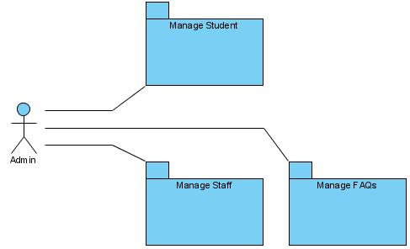

            - Admin Login User Case:

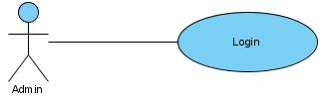

USE CASE # | UC01_01
USE CASE Name | Login
ACTOR | Admin
Purpose | Login to System Manager
Preconditions | Fill Username and Password
Postconditions in words | A new Batch login to System
Trigger | System Manage
Extended Use Cases
MAIN SUCCESSFUL SCENARIO | Actor Action | System Action
MAIN SUCCESSFUL SCENARIO | 1. Admin access system select function Login
MAIN SUCCESSFUL SCENARIO |  | 2. System display function  Login
MAIN SUCCESSFUL SCENARIO | 3. Admin enter username and Password.
 |  | 4. System processing check Username and Password (Validations)
OTHER SUCCESSFUL SCENARIOS |  | 5. Login successfully  If admin direct manager admin.  If client direct home page.
UNSUCCESSFUL SCENARIOS | Conditions | Actions
UNSUCCESSFUL SCENARIOS | 2a. If data invalid | System will be appearing a dialog message “Username or Password invalid. Let try it”
Developer
Creation date and last modified date

            - Staff Login User Case:

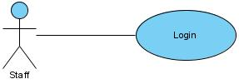

USE CASE # | UC02_01
USE CASE Name | Login
ACTOR | Staff
Purpose | - Login Staff to view, delete, upload assignments.  - Login Staff to viewing uploaded files by student by roll number.  - Login Staff to answer students' questions.  - The staff will assign the marks after evaluating the assignment once they are downloaded. The marks assigned will then be uploaded on the site through the links “marks”, based on the roll number.
Preconditions | Fill Username and Password
Postconditions in words | A new User login to System
Trigger | System Manage
Extended Use Cases
MAIN SUCCESSFUL SCENARIO | Actor Action | System Action
MAIN SUCCESSFUL SCENARIO | 1. Staff access system select function Login
MAIN SUCCESSFUL SCENARIO |  | 2. System display function  Login.
MAIN SUCCESSFUL SCENARIO | 3. Staff enter username and Password.
OTHER SUCCESSFUL SCENARIOS |  | 4. System processing check Username and Password (Validations).
5. Login successfully
If admin direct manager admin.
If client direct home page.
UNSUCCESSFUL SCENARIOS | Conditions | Actions
UNSUCCESSFUL SCENARIOS | 2a. If data invalid | System will be appearing a dialog message “Username or Password invalid. Let try it”
Developer
Creation date and last modified date

            - Student Login User Case:

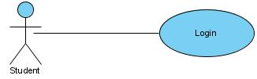

USE CASE # | UC03_03
USE CASE Name | Login
ACTOR | Student
Purpose | - Students must login for upload or download
Preconditions | Fill Username and Password
Postconditions in words | A new User login to System
Trigger | System Manage
Extended Use Cases
MAIN SUCCESSFUL SCENARIO | Actor Action | System Action
MAIN SUCCESSFUL SCENARIO | 1. Student access system select function Login
MAIN SUCCESSFUL SCENARIO |  | 2. System display function  Login.
MAIN SUCCESSFUL SCENARIO | 3. Student enter username and Password.
OTHER SUCCESSFUL SCENARIOS |  | 4. System processing check Username and Password (Validations).
5. Login successfully
If admin direct manager admin.
If client direct home page.
UNSUCCESSFUL SCENARIOS | Conditions | Actions
UNSUCCESSFUL SCENARIOS | 2a. If data invalid | System will be appearing a dialog message “Username or Password invalid. Let try it”
Developer
Creation date and last modified date

            - Manage Batch User Case:

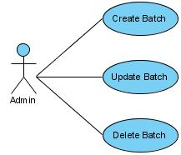

USE CASE # | UC04_01
USE CASE Name | Insert New Batch
ACTOR | Admin
Purpose | Add a new information to the System
Preconditions | Admin Login
Postconditions in words | A new Batch will be added to System
Trigger | Admin enable function add new Batch
Extended Use Cases
MAIN SUCCESSFUL SCENARIO | Actor Action | System Action
MAIN SUCCESSFUL SCENARIO | 1. Admin access system select function Batch management.
MAIN SUCCESSFUL SCENARIO |  | 2. System display function Batch management.
MAIN SUCCESSFUL SCENARIO | 3. Admin select function Add new Batch
MAIN SUCCESSFUL SCENARIO |  | 4. Form Add new is display
MAIN SUCCESSFUL SCENARIO | 5. Admin enter information into form add new Batch.
MAIN SUCCESSFUL SCENARIO | 6. Click “Save” button
MAIN SUCCESSFUL SCENARIO |  | 7. System process information and then saved to the database
OTHER SUCCESSFUL SCENARIOS | Step | Branching Action
UNSUCCESSFUL SCENARIOS | Conditions | Actions
UNSUCCESSFUL SCENARIOS | When admin click “Save” button to check the data was invalid | System will be appearing a dialog message “Information invalid. Let try it”
Developer
Creation date and last modified date

USE CASE # | UC04_02
USE CASE Name | Update Batch
ACTOR | Admin
Purpose | Edit information Batch in System
Preconditions | Admin login to the System
Postconditions in words | Batch information will be update add new information
Trigger | Admin enable function Edit Batch infortion.
Extended Use Cases
MAIN SUCCESSFUL SCENARIO | Actor Action | System Action
MAIN SUCCESSFUL SCENARIO | 1. Admin access system select function Batch management
MAIN SUCCESSFUL SCENARIO |  | 2. System display function Batch management
MAIN SUCCESSFUL SCENARIO | 3. Admin select search function Batch needs change
MAIN SUCCESSFUL SCENARIO |  | 4. System display Batch information to needs change.
MAIN SUCCESSFUL SCENARIO | 5. Admin change Batch information
MAIN SUCCESSFUL SCENARIO | 6. Admin click button Edit.
MAIN SUCCESSFUL SCENARIO |  | 7. System process information that admin entered then saved to the database
OTHER SUCCESSFUL SCENARIOS | Step | Branching Action
UNSUCCESSFUL SCENARIOS | Conditions | Actions
UNSUCCESSFUL SCENARIOS | When admin click “cancel” button | System will reset at previous information
Developer
Creation date and last modified date

USE CASE # | UC04_03
USE CASE Name | Delete Batch
ACTOR | Admin
Purpose | Delete information Batch
Preconditions | Admin login the System
Postconditions in words | Delete Batch information that already in the system
Trigger | Admin enable function Delete Batch information
Extended Use Cases
MAIN SUCCESSFUL SCENARIO | Actor Action | System Action
MAIN SUCCESSFUL SCENARIO | 1. Admin access system select function Batch management
MAIN SUCCESSFUL SCENARIO |  | 2. System display function Batch management
MAIN SUCCESSFUL SCENARIO | 3. Admin select search function Batch needs delete.
MAIN SUCCESSFUL SCENARIO |  | 4. System display Batch information to needs delete.
MAIN SUCCESSFUL SCENARIO | 5. Admin click button Delete
MAIN SUCCESSFUL SCENARIO |  | 6. The System display a message asking Admin select Yes or No
MAIN SUCCESSFUL SCENARIO | 7. Admin conduct selection
MAIN SUCCESSFUL SCENARIO |  | 8. System remove Batch information in database.
MAIN SUCCESSFUL SCENARIO |  | End User Case
OTHER SUCCESSFUL SCENARIOS | Step | Branching Action
UNSUCCESSFUL SCENARIOS | Conditions | Actions
UNSUCCESSFUL SCENARIOS | Admin click button yes | System processing information was removed then saved to the database
 | Admin click button no | System exit delete function then back the Batch management.
Developer
Creation date and last modified date

            - Manage Student User Case:

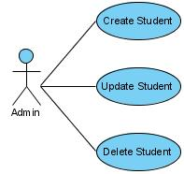

USE CASE # | UC05_01
USE CASE Name | Insert New Student
ACTOR | Admin
Purpose | Add a new information to the System
Preconditions | Admin Login
Postconditions in words | A new Student will be added to System
Trigger | Admin enable function add new Student
Extended Use Cases
MAIN SUCCESSFUL SCENARIO | Actor Action | System Action
MAIN SUCCESSFUL SCENARIO | 1. Admin access system select function Student management.
MAIN SUCCESSFUL SCENARIO |  | 2. System display function Student management.
MAIN SUCCESSFUL SCENARIO | 3. Admin select function Add new Student
MAIN SUCCESSFUL SCENARIO |  | 4. Form Add new is display
MAIN SUCCESSFUL SCENARIO | 5. Admin enter information into form add new Student.
MAIN SUCCESSFUL SCENARIO | 6. Click “Save” button
MAIN SUCCESSFUL SCENARIO |  | 7. System process information and then saved to the database
OTHER SUCCESSFUL SCENARIOS | Step | Branching Action
UNSUCCESSFUL SCENARIOS | Conditions | Actions
UNSUCCESSFUL SCENARIOS | When admin click “Save” button to check the data was invalid | System will be appearing a dialog message “Information invalid. Let try it”
Developer
Creation date and last modified date

USE CASE # | UC05_02
USE CASE Name | Update Student
ACTOR | Admin
Purpose | Edit information Student in System
Preconditions | Admin login to the System
Postconditions in words | Student information will be update add new information
Trigger | Admin enable function Edit Student information.
Extended Use Cases
MAIN SUCCESSFUL SCENARIO | Actor Action | System Action
MAIN SUCCESSFUL SCENARIO | 1. Admin access system select function Student management
MAIN SUCCESSFUL SCENARIO |  | 2. System display function Student management
MAIN SUCCESSFUL SCENARIO | 3. Admin select search function Student needs change
MAIN SUCCESSFUL SCENARIO |  | 4. System display Student information to needs change.
MAIN SUCCESSFUL SCENARIO | 5. Admin change Student information
MAIN SUCCESSFUL SCENARIO | 6. Admin click button Edit.
MAIN SUCCESSFUL SCENARIO |  | 7. System process information that admin entered then saved to the database
OTHER SUCCESSFUL SCENARIOS | Step | Branching Action
UNSUCCESSFUL SCENARIOS | Conditions | Actions
UNSUCCESSFUL SCENARIOS | When admin click “cancel” button | System will reset at previous information
Developer
Creation date and last modified date

USE CASE # | UC05_03
USE CASE Name | Delete Student
ACTOR | Admin
Purpose | Delete information Student
Preconditions | Admin login the System
Postconditions in words | Delete Student information that already in the system
Trigger | Admin enable function Delete Student information
Extended Use Cases
MAIN SUCCESSFUL SCENARIO | Actor Action | System Action
MAIN SUCCESSFUL SCENARIO | 1. Admin access system select function Student management
MAIN SUCCESSFUL SCENARIO |  | 2. System display function Student management
MAIN SUCCESSFUL SCENARIO | 3. Admin select search function Student needs delete.
MAIN SUCCESSFUL SCENARIO |  | 4. System display Student information to needs delete.
MAIN SUCCESSFUL SCENARIO | 5. Admin click button Delete
MAIN SUCCESSFUL SCENARIO |  | 6. The System display a message asking Admin select Yes or No
MAIN SUCCESSFUL SCENARIO | 7. Admin conduct selection
MAIN SUCCESSFUL SCENARIO |  | 8. System remove Student information in database.
MAIN SUCCESSFUL SCENARIO |  | End User Case
OTHER SUCCESSFUL SCENARIOS | Step | Branching Action
UNSUCCESSFUL SCENARIOS | Conditions | Actions
UNSUCCESSFUL SCENARIOS | Admin click button yes | System processing information was removed then saved to the database
 | Admin click button no | System exit delete function then back the Student management.
Developer
Creation date and last modified date

            - Manage Course User Case:

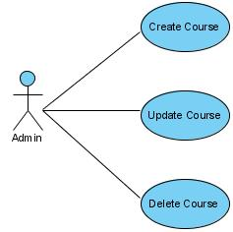

USE CASE # | UC06_01
USE CASE Name | Insert New Course
ACTOR | Admin
Purpose | Add a new information to the System
Preconditions | Admin Login
Postconditions in words | A new Course will be added to System
Trigger | Admin enable function add new Student
Extended Use Cases
MAIN SUCCESSFUL SCENARIO | Actor Action | System Action
MAIN SUCCESSFUL SCENARIO | 1. Admin access system select function Course management.
MAIN SUCCESSFUL SCENARIO |  | 2. System display function Course management.
MAIN SUCCESSFUL SCENARIO | 3. Admin select function Add new Course
MAIN SUCCESSFUL SCENARIO |  | 4. Form Add new is display
MAIN SUCCESSFUL SCENARIO | 5. Admin enter information into form add new Course.
MAIN SUCCESSFUL SCENARIO | 6. Click “Save” button
MAIN SUCCESSFUL SCENARIO |  | 7. System process information and then saved to the database
OTHER SUCCESSFUL SCENARIOS | Step | Branching Action
UNSUCCESSFUL SCENARIOS | Conditions | Actions
UNSUCCESSFUL SCENARIOS | When admin click “Save” button to check the data was invalid | System will be appearing a dialog message “Information invalid. Let try it”
Developer
Creation date and last modified date

USE CASE # | UC06_02
USE CASE Name | Update Course
ACTOR | Admin
Purpose | Edit information Course in System
Preconditions | Admin login to the System
Postconditions in words | Course information will be update add new information
Trigger | Admin enable function Edit Course information.
Extended Use Cases
MAIN SUCCESSFUL SCENARIO | Actor Action | System Action
MAIN SUCCESSFUL SCENARIO | 1. Admin access system select function Course management
MAIN SUCCESSFUL SCENARIO |  | 2. System display function Course management
MAIN SUCCESSFUL SCENARIO | 3. Admin select search function Course needs change
MAIN SUCCESSFUL SCENARIO |  | 4. System display Course information to needs change.
MAIN SUCCESSFUL SCENARIO | 5. Admin change Course information
MAIN SUCCESSFUL SCENARIO | 6. Admin click button Edit.
MAIN SUCCESSFUL SCENARIO |  | 7. System process information that admin entered then saved to the database
MAIN SUCCESSFUL SCENARIO | End User Case
OTHER SUCCESSFUL SCENARIOS | Step | Branching Action
UNSUCCESSFUL SCENARIOS | Conditions | Actions
UNSUCCESSFUL SCENARIOS | When admin click “cancel” button | System will reset at previous information
Developer
Creation date and last modified date

USE CASE # | UC06_03
USE CASE Name | Delete Course
ACTOR | Admin
Purpose | Delete information Course
Preconditions | Admin login the System
Postconditions in words | Delete Course information that already in the system
Trigger | Admin enable function Delete Course information
Extended Use Cases
MAIN SUCCESSFUL SCENARIO | Actor Action | System Action
MAIN SUCCESSFUL SCENARIO | 1. Admin access system select function Course management
MAIN SUCCESSFUL SCENARIO |  | 2. System display function Course management
MAIN SUCCESSFUL SCENARIO | 3. Admin select search function Course needs delete.
MAIN SUCCESSFUL SCENARIO |  | 4. System display Course information to needs delete.
MAIN SUCCESSFUL SCENARIO | 5. Admin click button Delete
MAIN SUCCESSFUL SCENARIO |  | 6. The System display a message asking Admin select Yes or No
MAIN SUCCESSFUL SCENARIO | 7. Admin conduct selection
MAIN SUCCESSFUL SCENARIO |  | 8. System remove Course information in database.
MAIN SUCCESSFUL SCENARIO |  | End User Case
OTHER SUCCESSFUL SCENARIOS | Step | Branching Action
UNSUCCESSFUL SCENARIOS | Conditions | Actions
UNSUCCESSFUL SCENARIOS | Admin click button yes | System processing information was removed then saved to the database
 | Admin click button no | System exit delete function then back the Course management.
Developer
Creation date and last modified date

            - Manage Staff User Case:

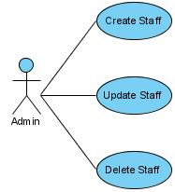

USE CASE # | UC07_01
USE CASE Name | Insert New Staff
ACTOR | Admin
Purpose | Add a new information to the System
Preconditions | Admin Login
Postconditions in words | A new Staff will be added to System
Trigger | Admin enable function add new Staff
Extended Use Cases
MAIN SUCCESSFUL SCENARIO | Actor Action | System Action
MAIN SUCCESSFUL SCENARIO | 1. Admin access system select function Staff management.
MAIN SUCCESSFUL SCENARIO |  | 2. System display function Staff management.
MAIN SUCCESSFUL SCENARIO | 3. Admin select function Add new Staff
MAIN SUCCESSFUL SCENARIO |  | 4. Form Add new is display
MAIN SUCCESSFUL SCENARIO | 5. Admin enter information into form add new Staff.
MAIN SUCCESSFUL SCENARIO | 6. Click “Save” button
MAIN SUCCESSFUL SCENARIO |  | 7. System process information and then saved to the database
OTHER SUCCESSFUL SCENARIOS | Step | Branching Action
UNSUCCESSFUL SCENARIOS | Conditions | Actions
UNSUCCESSFUL SCENARIOS | When admin click “Save” button to check the data was invalid | System will be appearing a dialog message “Information invalid. Let try it”
Developer
Creation date and last modified date

USE CASE # | UC07_02
USE CASE Name | Update Staff
ACTOR | Admin
Purpose | Edit information Staff in System
Preconditions | Admin login to the System
Postconditions in words | Staff information will be update add new information
Trigger | Admin enable function Edit Staff information.
Extended Use Cases
MAIN SUCCESSFUL SCENARIO | Actor Action | System Action
MAIN SUCCESSFUL SCENARIO | 1. Admin access system select function Staff management
MAIN SUCCESSFUL SCENARIO |  | 2. System display function Staff management
MAIN SUCCESSFUL SCENARIO | 3. Admin select search function Staff needs change
MAIN SUCCESSFUL SCENARIO |  | 4. System display Staff information to needs change.
MAIN SUCCESSFUL SCENARIO | 5. Admin change Staff information
MAIN SUCCESSFUL SCENARIO | 6. Admin click button Edit.
MAIN SUCCESSFUL SCENARIO |  | 7. System process information that admin entered then saved to the database
MAIN SUCCESSFUL SCENARIO | End User Case
OTHER SUCCESSFUL SCENARIOS | Step | Branching Action
UNSUCCESSFUL SCENARIOS | Conditions | Actions
UNSUCCESSFUL SCENARIOS | When admin click “cancel” button | System will reset at previous information
Developer
Creation date and last modified date

USE CASE # | UC07_03
USE CASE Name | Delete Staff
ACTOR | Admin
Purpose | Delete information Staff
Preconditions | Admin login the System
Postconditions in words | Delete Staff information that already in the system
Trigger | Admin enable function Delete Staff information
Extended Use Cases
MAIN SUCCESSFUL SCENARIO | Actor Action | System Action
MAIN SUCCESSFUL SCENARIO | 1. Admin access system select function Staff management
MAIN SUCCESSFUL SCENARIO |  | 2. System display function Staff management
MAIN SUCCESSFUL SCENARIO | 3. Admin select search function Staff needs delete.
MAIN SUCCESSFUL SCENARIO |  | 4. System display Staff information to needs delete.
MAIN SUCCESSFUL SCENARIO | 5. Admin click button Delete
MAIN SUCCESSFUL SCENARIO |  | 6. The System display a message asking Admin select Yes or No
MAIN SUCCESSFUL SCENARIO | 7. Admin conduct selection
MAIN SUCCESSFUL SCENARIO |  | 8. System remove Course information in database.
MAIN SUCCESSFUL SCENARIO |  | End User Case
OTHER SUCCESSFUL SCENARIOS | Step | Branching Action
UNSUCCESSFUL SCENARIOS | Conditions | Actions
UNSUCCESSFUL SCENARIOS | Admin click button yes | System processing information was removed then saved to the database
 | Admin click button no | System exit delete function then back the Course management.
Developer
Creation date and last modified date

            - Manage FAQs User Case:

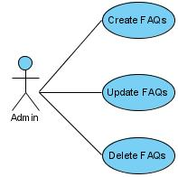

USE CASE # | UC08_01
USE CASE Name | Insert New FAQs
ACTOR | Admin
Purpose | Add a new information to the System
Preconditions | Admin Login
Postconditions in words | A new FAQs will be added to System
Trigger | Admin enable function add new FAQs
Extended Use Cases
MAIN SUCCESSFUL SCENARIO | Actor Action | System Action
MAIN SUCCESSFUL SCENARIO | 1. Admin access system select function FAQs management.
MAIN SUCCESSFUL SCENARIO |  | 2. System display function FAQs management.
MAIN SUCCESSFUL SCENARIO | 3. Admin select function Add new FAQs
MAIN SUCCESSFUL SCENARIO |  | 4. Form Add new is display
MAIN SUCCESSFUL SCENARIO | 5. Admin enter information into form add new FAQs.
MAIN SUCCESSFUL SCENARIO | 6. Click “Save” button
MAIN SUCCESSFUL SCENARIO |  | 7. System process information and then saved to the database
OTHER SUCCESSFUL SCENARIOS | Step | Branching Action
UNSUCCESSFUL SCENARIOS | Conditions | Actions
UNSUCCESSFUL SCENARIOS | When admin click “Save” button to check the data was invalid | System will be appearing a dialog message “Information invalid. Let try it”
Developer
Creation date and last modified date

USE CASE # | UC08_02
USE CASE Name | Update FAQs
ACTOR | Admin
Purpose | Edit information FAQs in System
Preconditions | Admin login to the System
Postconditions in words | FAQs information will be update add new information
Trigger | Admin enable function Edit FAQs information.
Extended Use Cases
MAIN SUCCESSFUL SCENARIO | Actor Action | System Action
MAIN SUCCESSFUL SCENARIO | 1. Admin access system select function FAQs management
MAIN SUCCESSFUL SCENARIO |  | 2. System display function FAQs management
MAIN SUCCESSFUL SCENARIO | 3. Admin select search function FAQs needs change
MAIN SUCCESSFUL SCENARIO |  | 4. System display FAQs information to needs change.
MAIN SUCCESSFUL SCENARIO | 5. Admin change FAQs information
MAIN SUCCESSFUL SCENARIO | 6. Admin click button Edit.
MAIN SUCCESSFUL SCENARIO |  | 7. System process information that admin entered then saved to the database
OTHER SUCCESSFUL SCENARIOS | Step | Branching Action
UNSUCCESSFUL SCENARIOS | Conditions | Actions
UNSUCCESSFUL SCENARIOS | When admin click “cancel” button | System will reset at previous information
Developer
Creation date and last modified date

USE CASE # | UC08_03
USE CASE Name | Delete FAQs
ACTOR | Admin
Purpose | Delete information FAQs
Preconditions | Admin login the System
Postconditions in words | Delete FAQs information that already in the system
Trigger | Admin enable function Delete FAQs information
Extended Use Cases
MAIN SUCCESSFUL SCENARIO | Actor Action | System Action
MAIN SUCCESSFUL SCENARIO | 1. Admin access system select function FAQs management
MAIN SUCCESSFUL SCENARIO |  | 2. System display function FAQs management
MAIN SUCCESSFUL SCENARIO | 3. Admin select search function FAQs needs delete.
MAIN SUCCESSFUL SCENARIO |  | 4. System display FAQs information to needs delete.
MAIN SUCCESSFUL SCENARIO | 5. Admin click button Delete
MAIN SUCCESSFUL SCENARIO |  | 6. The System display a message asking Admin select Yes or No
MAIN SUCCESSFUL SCENARIO | 7. Admin conduct selection
MAIN SUCCESSFUL SCENARIO |  | 8. System remove FAQs information in database.
MAIN SUCCESSFUL SCENARIO |  | End User Case
OTHER SUCCESSFUL SCENARIOS | Step | Branching Action
UNSUCCESSFUL SCENARIOS | Conditions | Actions
UNSUCCESSFUL SCENARIOS | Admin click button yes | System processing information was removed then saved to the database
 | Admin click button no | System exit delete function then back the FAQs management.
Developer
Creation date and last modified date

            - Student Manage Use Case :

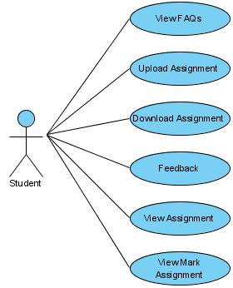

USE CASE # | UC09_01
USE CASE Name | View FAQs
ACTOR | STUDENT
Purpose | View FAQs

Preconditions
Postconditions in words | Student view FAQs
Trigger
Extended Use Cases
 | 1. Student select function FAQs management
 |  | 2. System display function FAQs management
 |  | 3. System display FAQs
OTHER SUCCESSFUL SCENARIOS
UNSUCCESSFUL SCENARIOS | Conditions | Actions
Developer
Creation date and last modified date

USE CASE # | UC09_02
USE CASE Name | Upload Assignment
ACTOR | STUDENT
Purpose | Upload Assignment

Preconditions
Postconditions in words | Student Upload Assignment
Trigger | Enable function Upload File
Extended Use Cases
 | 1. Student access system select function “File Upload” .
 |  | 2. System display function “File Upload” .
 | 3. Student select function Upload .
 |  | 4. Form Upload is display
 | 5. Student select file need Upload
 | 6. Click button Brower
 | 7. Click button Upload
 |  | 8. System processing and then saved to the database.
OTHER SUCCESSFUL SCENARIOS
UNSUCCESSFUL SCENARIOS | Conditions | Actions
Developer
Creation date and last modified date

USE CASE # | UC09_03
USE CASE Name | Download Assignment
ACTOR | STUDENT
Purpose | Student download Assignment
Preconditions | Student Login to the system
Postconditions in words | Student download Assignment
Trigger | System enable function Download Assignment
Extended Use Cases
 | 1. Student access system select “Link download” Assignments
 |  | 2. System display List Assignments
 | 3. Student select to download
OTHER SUCCESSFUL SCENARIOS
UNSUCCESSFUL SCENARIOS | Conditions | Actions
Developer
Creation date and last modified date

USE CASE # | UC09_04
USE CASE Name | Send Feedback
ACTOR | STUDENT
Purpose | Send Feedback

Preconditions
Postconditions in words | Student send Feedback
Trigger
Extended Use Cases
 | 1. Student select “Feedback” menu
 |  | 2. Form “Feedback” will be displayed
 | 3. Student input information
 | 4. Student click “submit” button
 |  | 5. System process information that Student entered then saved to the database
OTHER SUCCESSFUL SCENARIOS
UNSUCCESSFUL SCENARIOS | Conditions | Actions
Developer
Creation date and last modified date

USE CASE # | UC09_05
USE CASE Name | View Assignment
ACTOR | STUDENT
Purpose | View Assignments
Preconditions | Student Login System
Postconditions in words | View Assignments that already in the system
Trigger
Extended Use Cases
 | 1. Student access system select “List Assignments”
 |  | 2. System display List Assignments
OTHER SUCCESSFUL SCENARIOS
UNSUCCESSFUL SCENARIOS | Conditions | Actions
Developer
Creation date and last modified date

USE CASE # | UC09_06
USE CASE Name | View Mark
ACTOR | Student
Purpose | View Mark
Preconditions | Student Login System
Postconditions in words | View Mark that already in the system
Trigger
Extended Use Cases
 | 1. Student access system select form “Mark View”.
 |  | 2. System display form search
 | 3. Student entered Rollnumber click button search.
 |  | 4. System display “ Detail Mark”
OTHER SUCCESSFUL SCENARIOS
UNSUCCESSFUL SCENARIOS | Conditions | Actions
Developer
Creation date and last modified date

            - Staff Manage Use Case :

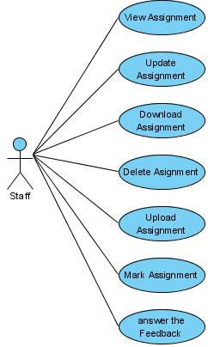

USE CASE # | UC10_01
USE CASE Name | View Assignments
ACTOR | Staff
Purpose | View Assignments
Preconditions | Staff Login System
Postconditions in words | View Assignments that already in the system.
Trigger
Extended Use Cases
 | 1. Staff access system select form “Assignments”.
 |  | 2. System display List Assignments.
OTHER SUCCESSFUL SCENARIOS
UNSUCCESSFUL SCENARIOS | Conditions | Actions
Developer
Creation date and last modified date

USE CASE # | UC10_02
USE CASE Name | Mark Assignments
ACTOR | Staff
Purpose | Mark Assignment
Preconditions | Staff Login System
Postconditions in words | Mark Assignments that already in the system
Trigger
Extended Use Cases
 | 1. Staff access system select “List Assignment”.
 |  | 2. System display List Assignments
 | 3. Staff download Assignments
 |  | 4. Evaluating the assignments once they are downloaded
OTHER SUCCESSFUL SCENARIOS
UNSUCCESSFUL SCENARIOS | Conditions | Actions
Developer
Creation date and last modified date

USE CASE # | UC10_03
USE CASE Name | Update Assignment
ACTOR | Staff
Purpose | Edit Assignment
Preconditions | Staff Login System
Postconditions in words | Edit Assignment information that already in the system
Trigger
Extended Use Cases
MAIN SUCCESSFUL SCENARIO | Actor Action | System Action
MAIN SUCCESSFUL SCENARIO | 1. Staff access to the system select Assignment
MAIN SUCCESSFUL SCENARIO |  | 2. System display Assignments.
MAIN SUCCESSFUL SCENARIO | 3. Staff select search function Assignments needs change
MAIN SUCCESSFUL SCENARIO |  | 4. System display assignments information to needs change.
MAIN SUCCESSFUL SCENARIO | 5. Staff change Assignments information.
MAIN SUCCESSFUL SCENARIO | 6. Staff click button Edit
MAIN SUCCESSFUL SCENARIO |  | 7. System process information that admin entered then saved to the database
OTHER SUCCESSFUL SCENARIOS
UNSUCCESSFUL SCENARIOS | Conditions | Actions
UNSUCCESSFUL SCENARIOS | When admin click “cancel” button | System will reset at previous information
Developer
Creation date and last modified date

USE CASE # | UC10_04
USE CASE Name | Download Assignment
ACTOR | Staff
Purpose | Download Assignment

Preconditions
Postconditions in words | Staff download Assignment
Trigger
Extended Use Cases
1. Staff select
“Link download” Assignment
 |  | 2. Staff click to download
OTHER SUCCESSFUL SCENARIOS
UNSUCCESSFUL SCENARIOS | Conditions | Actions
Developer
Creation date and last modified date

USE CASE # | UC10_05
USE CASE Name | Delete Assignment
ACTOR | Staff
Purpose | Delete Assignment information
Preconditions | Staff Login System
Postconditions in words | Delete Assignment information that already in the system
Trigger
Extended Use Cases
MAIN SUCCESSFUL SCENARIO | Actor Action | System Action
MAIN SUCCESSFUL SCENARIO | 1. Staff access to the system select function Assignments
MAIN SUCCESSFUL SCENARIO |  | 2. System display function Assignments
MAIN SUCCESSFUL SCENARIO | 3. Staff select search function Assignment needs delete
MAIN SUCCESSFUL SCENARIO |  | 4. System display Assignments information to needs delete.
MAIN SUCCESSFUL SCENARIO | 5. Staff click button  Delete
MAIN SUCCESSFUL SCENARIO |  | 6. The system display a message asking Staff select Yes or No
MAIN SUCCESSFUL SCENARIO | 7. Staff conduct selection
MAIN SUCCESSFUL SCENARIO |  | 8. System remove Assignments information in database.
MAIN SUCCESSFUL SCENARIO | End User Case
OTHER SUCCESSFUL SCENARIOS
UNSUCCESSFUL SCENARIOS | Conditions | Actions
UNSUCCESSFUL SCENARIOS | - Staff click button Yes | System processing information was removed then saved to the database.
UNSUCCESSFUL SCENARIOS | - Staff click button No | System exit delete function then back the Assignments.
Developer
Creation date and last modified date

USE CASE # | UC09_02
USE CASE Name | Upload Assignment
ACTOR | STAFF
Purpose | Upload Assignment
Preconditions | Staff Login System
Postconditions in words | Staff Upload Assignment
Trigger | Enable function Upload File
Extended Use Cases
 | 1. Staff access system select function “File Upload” .
 |  | 2. System display function “File Upload” .
 | 3. Staff select function Upload .
 |  | 4. Form Upload is display
 | 5. Staff select file need Upload
 | 6. Click button Brower
 | 7. Click button Upload
 |  | 8. System processing and then saved to the database.
OTHER SUCCESSFUL SCENARIOS
UNSUCCESSFUL SCENARIOS | Conditions | Actions
Developer
Creation date and last modified date

USE CASE # | UC10_07
USE CASE Name | Answer the Feedback
ACTOR | Staff
Purpose | Answer Feedback

Preconditions
Postconditions in words | Staff answer the Feedback
Trigger
Extended Use Cases
 | 1. Staff select “Feedback” menu
 |  | 2. Staff select question feedback click "Answer"
OTHER SUCCESSFUL SCENARIOS
UNSUCCESSFUL SCENARIOS | Conditions | Actions
Developer
Creation date and last modified date

- Class Diagram.

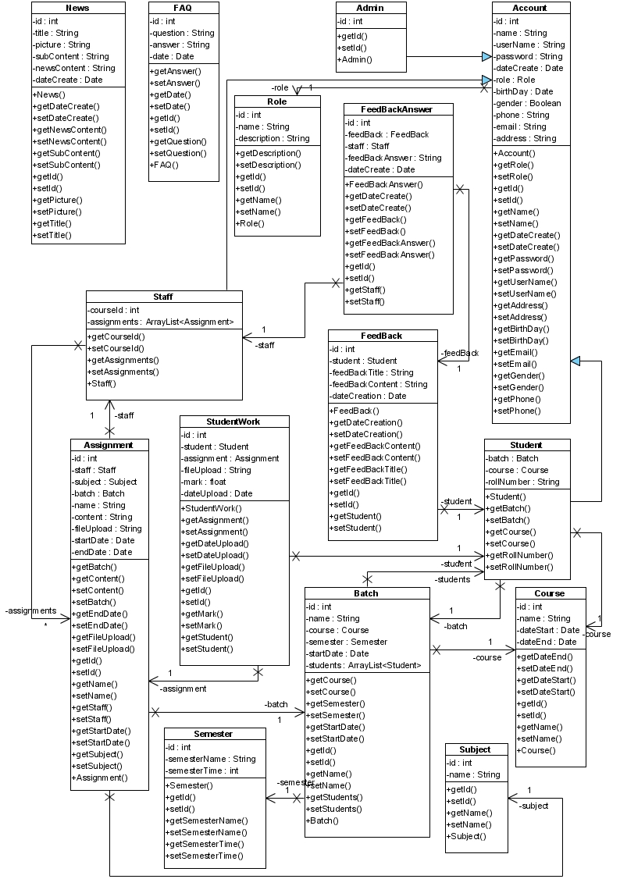
- Design Details:

- Page Index:

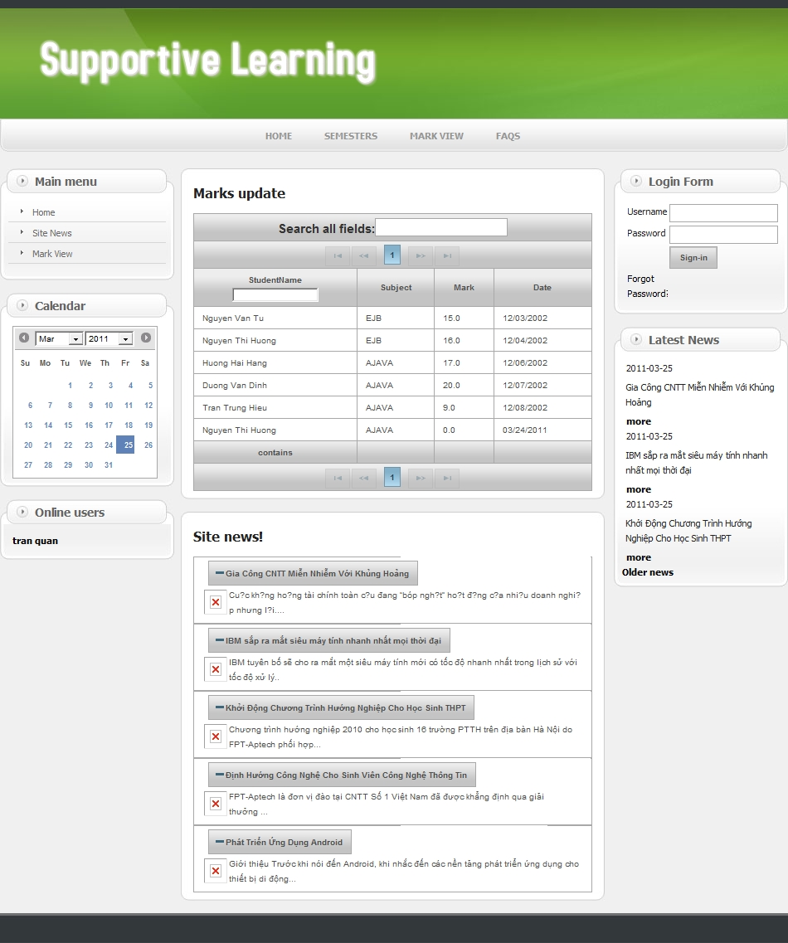

- Page Assignment:

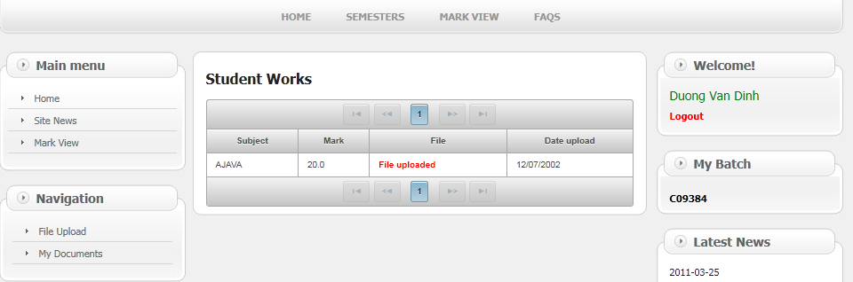

- Page MarkView:

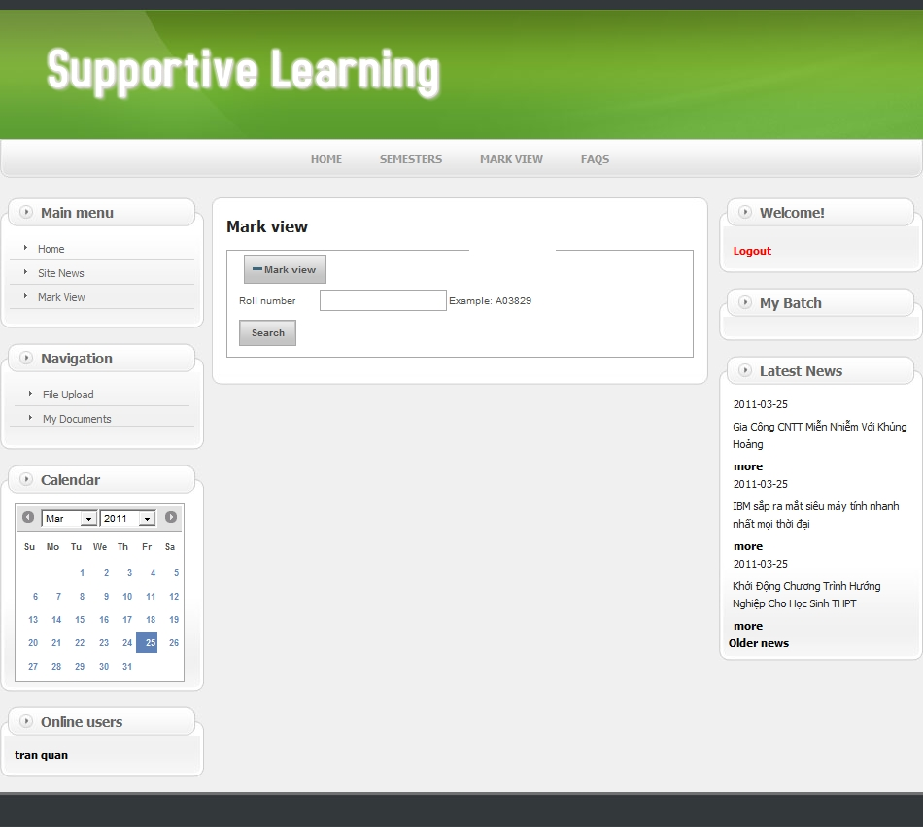

- Search MarkView Detail:

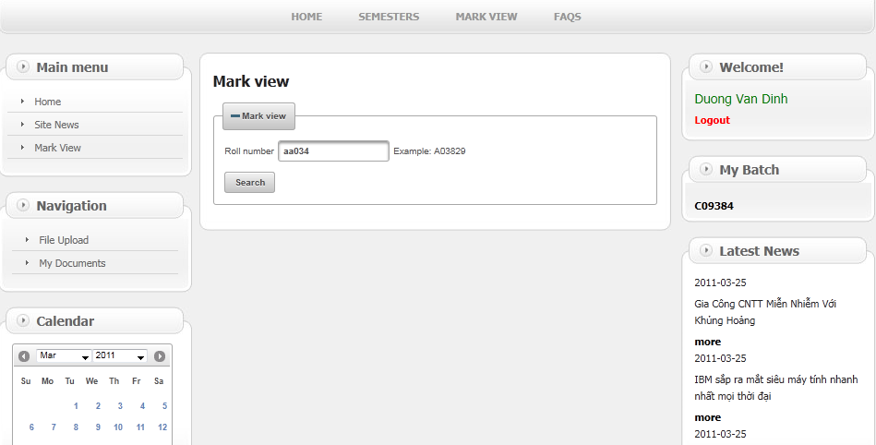

- MarkView Detail:

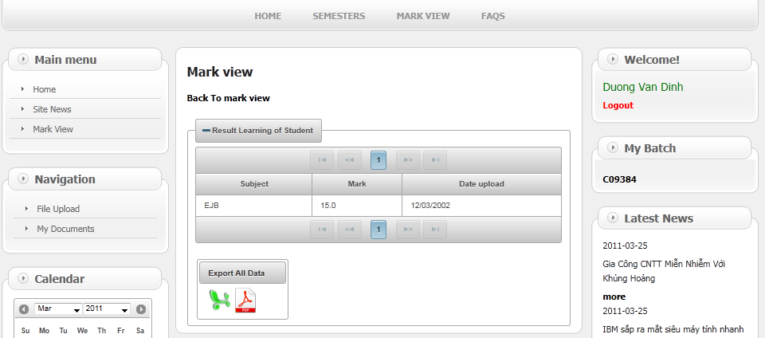

- Page News Details:

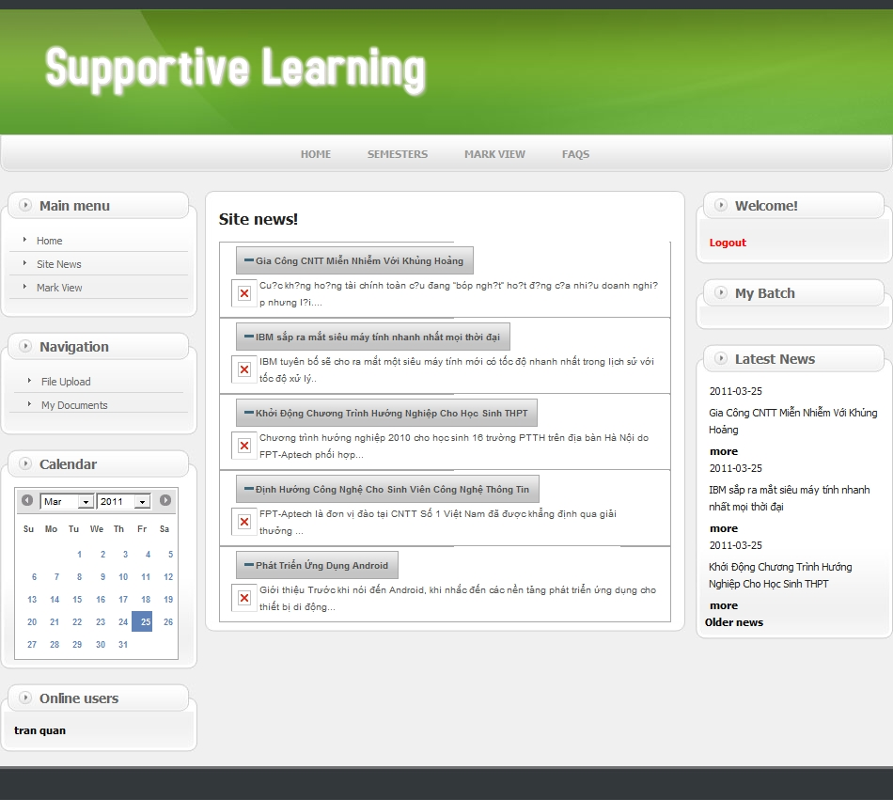

- Page Staff Assignment Management Detail:

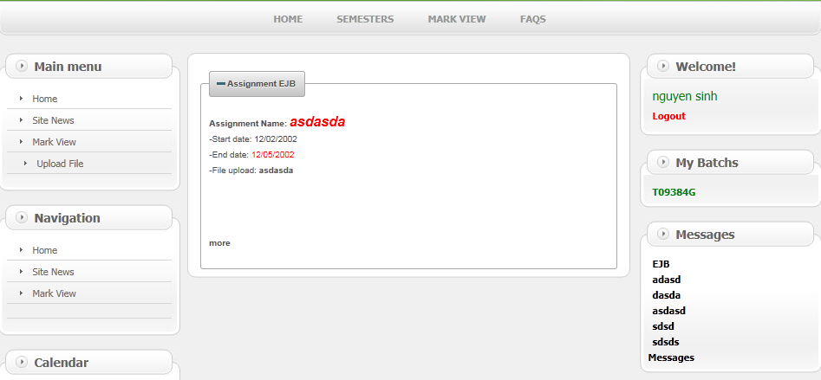

- Page Upload Assignment:

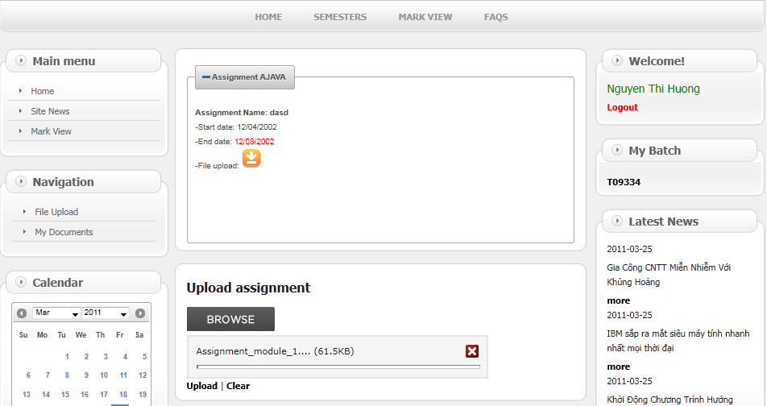
- Upload Success:

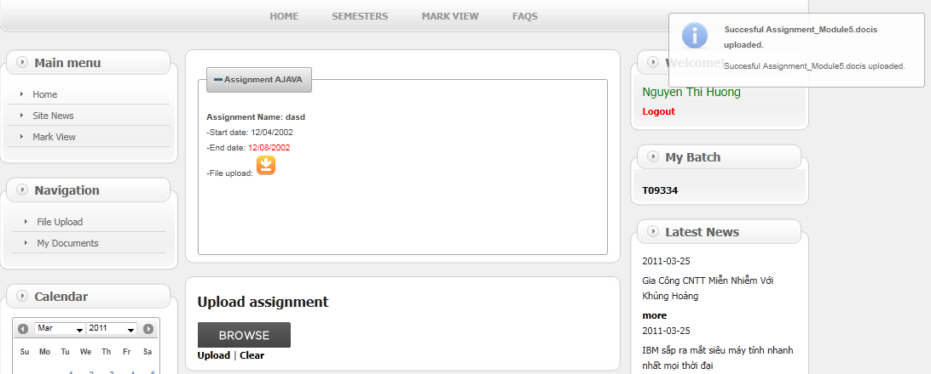

- Page Replay Feedback:

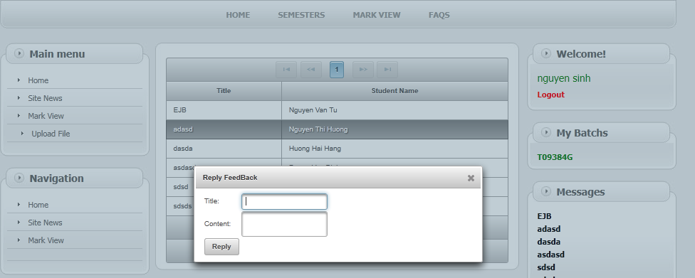

- Page Message:

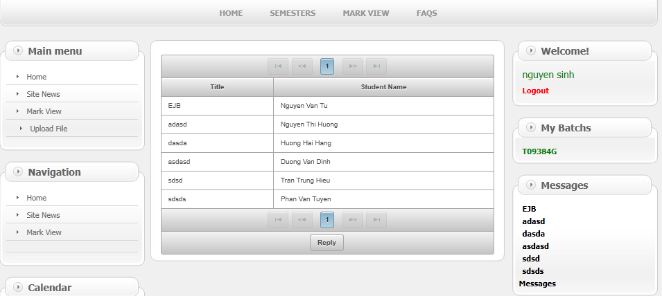

- Staff view assignments by student upload

